Intentional Setting, Fragmented Privacy, Invisible Community: The Paradox of Liminality in Chốn Riêng café at District 7
Course: Ethnographic Research Methods

“Do you want to study-date with me?”
“Where?”
“Chốn Riêng café? You wanna try? It is a good study coffee that I was taken to.”
“Okay. Let me try!”
On a random day in August 2024, my boyfriend asked me to have a study-date at “Chốn Riêng café” as a refreshing way to engage in productive bonding time. That was the first time I heard and came to one branch of Chốn Riêng café in District 10, which gave me a strong initial impression of a cozy café hidden under a long alley from a hustle avenue. One year later from my first encounter, the launching of a new location in District 7 urged me to visit Chốn Riêng café again, partly because of my curiosity to revisit my favorite space with possible proximity, and partly because of the practical need for a study spot with my friend.
Following Google Maps for over twenty minutes, I discovered Chốn Riêng café deep within an alley off Tran Xuan Soan street, District 7, such a secluded spot reminiscent of the previous one. Conventionally, Tran Xuan Soan is perceived as a rather mundane road situated on the periphery of District 7, and notably running alongside the Te Canal - one branch of the Saigon River, where frequent tidal surges disrupt the livelihoods and daily commutes of residents. The street’s rhythm remains in a perpetual state of frenetic activity, defined by dense flows of traffic, street vendors, or food and fruit stalls scattered across the pavement, all of which entwine in a chaotic dance from early morning until late at night. The official address of Chốn Riêng café (District 7) is 791/25a Tran Xuan Soan street, which lies in quiet solitude, deep inside a small alley, completely contrasted to the dynamic energy of the main road outside. Scattered with gravel, wild plants, and residential houses, Chốn Riêng café displayed merely the same as other residential houses around, with the black iron fence, the three-step cement staircase guiding to a ground floor with nothing - no tables, no chairs, no people - just like an actual abandoned house. The only exception is a small, illuminated rectangular box reading ‘chon rieng’ - a subtle sign that is more than a mere residence.
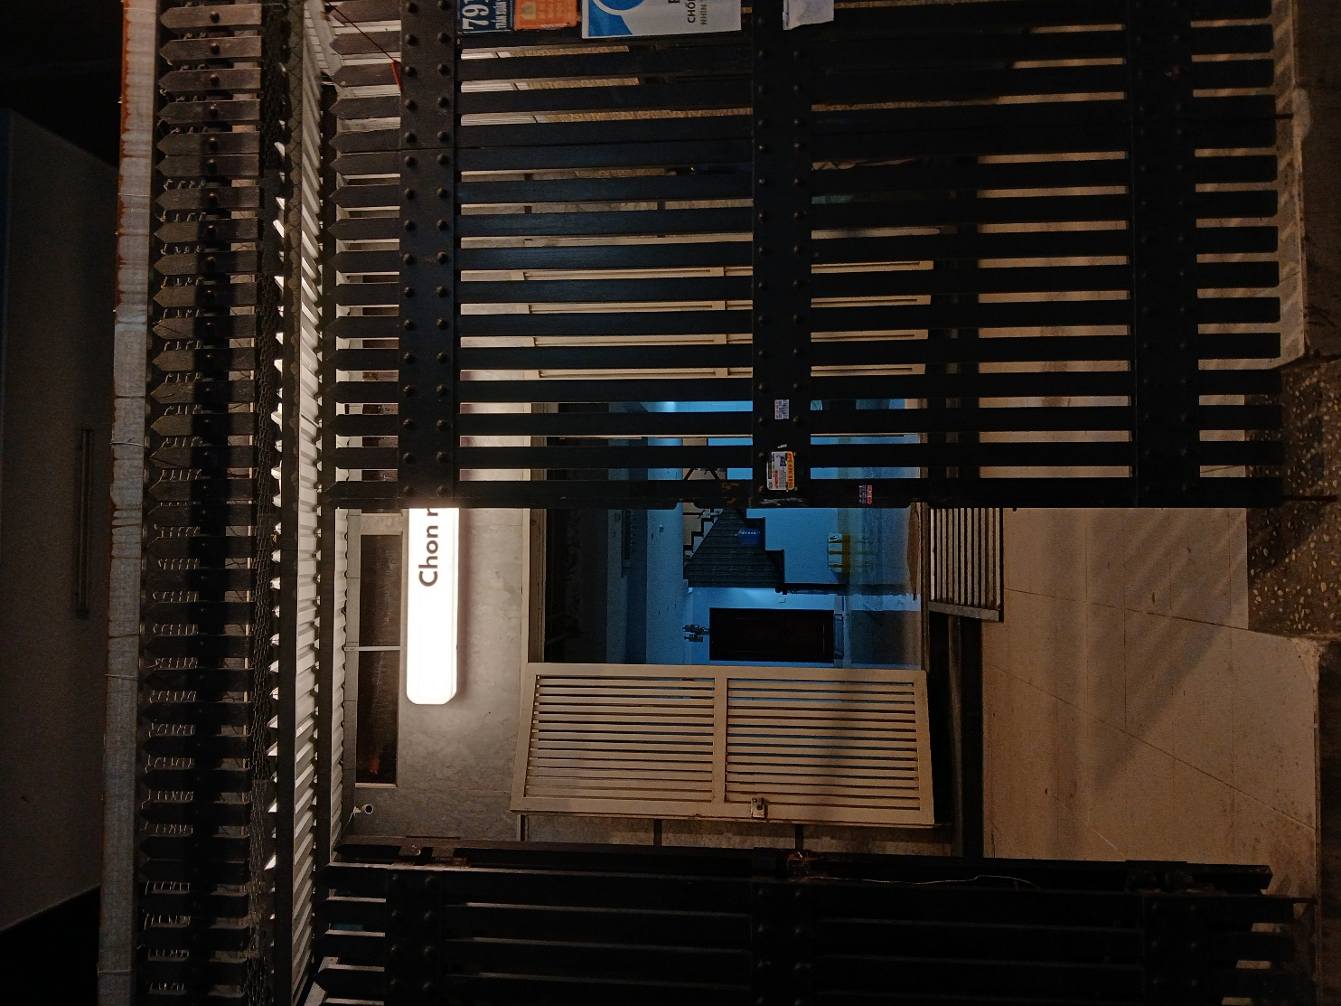
Figure 1: The outer appearance of Chốn Riêng café in District 7
Navigating the narrow staircase with lingering skepticism about Chốn Riêng café’s existence in this place, I was once again struck by the scene behind the main room door on the second floor: people glued to their screens, seemingly immersed in their own solitary zones within the silence and dim yellow light. Someone was silently weeping in a corner. A couple was leaning on each other and watching a movie. Another was crocheting with ears enclosed by headphones. Each individual was engaged in their own private act, seemingly alone, yet I held a belief in an intimate connection, which may be invisible but palpable, existing amongst them. A living community. And thus, my ethnography began, driven by a curiosity about such spatial perception of privacy and public space, and the nature of community at Chốn Riêng café.
Drawing on distinct fieldwork and interactions with both customer and staff, I argue that Chốn Riêng café is not merely a commercial establishment, but a manifestation of a specific liminal space, intentionally curated to nurture the imagined privateness of the self in negotiation with the public sphere. Yet, paradoxically, a new form of communitas emerges among the café’s inhabitants, invisibly constructed by the shared desire and tacit cultural norms within the visible space.
Palpable and Intentional - The Setting of Chốn Riêng café.
Chốn Riêng café, from its name, evokes the sense of absolute separateness and privateness. In Vietnamese, Chốn means a site, but it is often used as a beautiful and aesthetic term in poems or literature rather than in verbal communication. Riêng conveys the solitude feeling that excludes oneself from the others. Then, the name of this café, at the first time, arouses the imagination of a place defined by utmost privacy, discretion, and separateness.
The setting of Chốn Riêng café is intentionally curated to prioritize seclusion and self-focus for productivity; yet it remains palpably open to intimacy between those seated side-by-side in such a public space. The special configuration here includes the mixed usage of big, rectangular and small square wooden tables, the arrangement of table and chair within each room, the display of dim yellow lamp on each table with the power outlets to meet the studying demand, the decoration of black vinyl records, colorful spools of thread, beige handwritten notes, and monochrome paintings on the walls. This intentionality is manifested explicitly to the patrons with diverse feelings and interpretation. Specifically, “dark”, “cozy”, and “vintage” are the most common words that customers use to describe the café’s spatial vibe. Long, who is a final year student, visits three different locations of Chốn Riêng café including this one in District 7, shared that “Chốn Riêng is remarkably consistent in maintaining a deeply dimmed atmosphere, illuminated only by a solitary, subdued lighting, just sufficient to prevent eye strain”, which is very suitable to focus solely on studying or working on both laptops and papers. For Hoa - a customer who has visited Chốn Riêng café in District 7 for two times, the decor here fosters a “cozy and work-oriented mindset”, with sticky notes and yarn spools smartly chosen to evoke imagination and creativity for students. Moreover, she pays more attention to the general design of the café that has a “very distinct subdividing nature”: the entire café is subdivided into a few rooms; rooms are subdivided into a number of zones; zones are subdivided into tables, which apparently create a sense of separateness with each other in a same space. According to a staff of Chốn Riêng café, the founder curated this space with the intention that it minimizes direct face-to-face orientation, eye contact with others, and the scrutiny of others on ourselves. In this way, the setting of Chốn Riêng café is palpably designed as a space to cultivate the privacy for customers themselves, and the needs of studying and creativity within that space. However, the inescapable reality of co-existing with strangers in a public sphere renders this intentional setting paradoxical, leaving the customers’ sense of privacy blurring into ambiguity and fragmentation.
Fragmented and Imagined - Privateness in Negotiating with the Public Sphere.
There are two divergent narratives regarding the sense of privacy at Chốn Riêng café: one perceiving it as sufficiently private and comfortable, while the other argues that the privacy feels incomplete and not fully comfortable. This leads to my perspective on fragmentation, where privacy is broken into discrete, discontinuous segments that vary subjectively from person to person. Moreover, it highlights the imagined nature of this privacy, reflected in the fact that seclusion at Chốn Riêng café is not factually real, but is rather a mental construct, intentionally fabricated to satisfy the needs of the self.
On the one hand, Chốn Riêng café is perceived as a sufficiently secluded and domestic space, effectively fulfilling the specific expectations of its customers. Nga, a customer who came to Chốn Riêng café twice, shared about her feeling of privacy and “home” within the space. She emphasized the comfort to “do anything without anyone caring or judging me” - the privacy and freedom without scrutiny; also the “switching beds” feeling compared to her home as she felt she could sleep or study comfortably there. As a couple choosing Chốn Riêng café for a date, Nga and her friend express their “không ngại” feeling (the lack of inhibition and embarrassment) when they hug or lean on each other. Within this environment, they believe that no one minds anyone else, intimacy is normalized among other couples, and individuals should feel liberated to act on their desire without the fear of external judgement. Similarly, this sense of “not being seen, judged, minded” and “focusing on my work” is shared widely for all customers I talked to, and including myself when I focus solely on my work and do not care about the others.
On the other hand, in fact, this is always an illusion because they are in the public sphere, where everyone has the ability to observe and be observed by another one.
“It is not that I’m imagining it; it’s simply because I CAN look at others, so they CAN look back at me if they want to. Even if they aren’t looking right now, there is always a certain probability that they might be.” - Hoa strongly stated about her acknowledgement of reciprocal visibility and scrutiny at Chốn Riêng café.
Actually, the presence of myself observing them to understand the living dynamics within this space also proves Hoa’s argument. Besides her, other customers also share this sentiment, reporting a lack of complete seclusion and comfort driven by the same anxiety: the ever-present possibility of being scrutinized. For example, An highlighted a specific discomfort regarding involuntary table-sharing with strangers. “If I’m sitting alone and facing another solo person, it’s fine. But if I’m facing a couple, it can be quite distracting”. This visual intrusion conflicts with her predetermined expectation of solitary work at Chốn Riêng café, leading to the dissatisfaction and “not private” feeling. Interestingly, the contrast between Nga’s perspective as part of a couple and An’s solitary presence illuminates the complex interplay between individuals entering this café with divergent purposes: bonding with friends or focusing on work. Moreover, it reveals an entanglement of obligations toward oneself versus others, and the undeniable existence of others within one’s private sphere.
The sense of insufficient privacy and comfort, specifically the way the verdict of “sufficiently private” fluctuates based on seating, individual needs, and perceived scrutiny, exemplifies the fragmented and discontinuous nature of privacy here. Furthermore, this validates the imagined privacy at Chốn Riêng café: customers actively construct a narrative of being observed, driven either by willfully disregarding the presence of others, by the luck of not having encountered a gaze yet, or by a deliberate choice to believe in this illusion to safeguard their desire for self-absorption in a space where they came expecting exactly that. And then, if one cannot fit oneself in this intentionally setting space, they can choose to leave Chốn Riêng for those who can adapt themselves within this invisible but resilient culture and community.
Invisible and Ambiguous - The sense of ‘Communitas’ Emerging within the Liminality of a Public Place.
- Do you think Chốn Riêng is a community?
- No. I only focus on myself. If I had to be forced into a community, it would be a community where everyone has their own goals and just minds their own business.
- I have no need to belong to any community here. Nor do I feel like I have to connect or bond with the other people in the space.
- I think when I sit there for three to four hours, quite naturally, I can begin to feel a vague sense of connection with the one who has sat through that same timeframe with us.
Skeptical of the existence of any form of community within Chốn Riêng café, I sought to uncover traces of human connection, whether revealed through tangible manifestations or sensed through invisible and ambiguous feelings. Their responses vacillated: at once seemingly evoking signs of community, yet simultaneously attempting to deny any bond, instead insisting on the distinct individuality of each individual. Nevertheless, I am inclined to argue that Chốn Riêng café is cultivating an invisible community, situated on the ambiguous boundary of perception between public and private space. This phenomenon, through the lens of Victor Turner, can be viewed as the emergence of communitas within the liminality of Chốn Riêng café.
Liminality fundamentally refers to a condition (or persons) “betwixt and between” the established positions in social and cultural space (Turner, 1969). In other words, its entity eludes the normal network of classifications about a visible social existence. The communitas emerges from this liminality as a modality of social relationship characterized by an unstructured “area of common living” and equality, which stands in contrast to the differentiated, hierarchical nature of standard social structure (Turner, 1969). In Chốn Riêng café, the liminality manifests as the ambiguous positioning of the self, suspended between the thresholds of the absolute privateness and public sphere. Through the negotiation of this paradox, customers transform into liminal entities, stripping of their usual social norms of self-isolation or indifference. Not only the equal existence of every patron, the relationship between staff and customers within such a commercial space is seemingly free of the original standard of a serving and a served one. “We are university students like you all. We understand” - Mai, a staff member, reasons their sentiment in helping to lend the battery charger, find missing stuff, and make friends closely with customers. The perspective from Thanh, a customer, also manifests that fair relation with staff - “I don’t perceive them as a server but a supporter, as they do not really serve me drinks or food, but they are always available to support during my experience”. In doing so, all inhabitants at Chốn Riêng café transcend into a state where the boundary between self and other, between the customer and staff dissolves.
Instead, they perceive themselves as part of a latent communitas, which is shaped by a shared submission to the explicit and implicit codes of respect and silence at Chốn Riêng. “Đi nhẹ, nói khẽ, cười duyên” (“to walk softly, speak quietly, and smile gracefully”) was a major phrase here, describing a refined, gentle, subtle, and well-mannered person with graceful behavior. In the context of Chốn Riêng, it serves as a rule explicitly on paper, through the café’s Wi-Fi password - dinhenoikhecuoiduyen, and implicitly through the customers shared, unspoken understanding and mutual reminders. If somebody discusses too loudly and annoys other customers, staff will come and remind them gently to keep the standard of silent atmosphere. Mai also recounted the exclusive and filtered nature of Chốn Riêng, when some customers express frustration and choose to depart simply because they misalign with the quiet expectation and cannot socialize comfortably in this space. Apparently, the awareness about the invisible culture here is what can filter the right inhabitant of this communitas. Thus, the sense of community within this café is not defined by a vivid presence, but functions ambiguously as a communitas constructed upon the liminality of the private perception and the shared culture within Chốn Riêng space and others’ existence.
Conclusion & Acknowledgement
This ethnography investigates Chốn Riêng café in District 7 as an exemplary of the intentional spatial construction occurring in the rise of study café and public workspace for young people. The study traces the tension between the intentional arrangement of the physical space and the fragmented, imagined sense of privacy that customers perceive when negotiating their desire for intimacy within a public setting. Ultimately, Chốn Riêng transcends the definition of a mere public café inhabited by disconnected strangers; rather, it becomes a communitas formed within the ambiguity and liminality of the humans there.
In completing this ethnography, I must acknowledge the book Jon Krakauer’s “Into the Wild” (1997) for inspiring my storytelling style: following the voices of the main characters while remaining present as a witness to their stories, evoking genuine emotion through honest description. Like Krakauer’s journey understanding Christopher McCandless by retracing his diary, I have sought to collect various perspectives and testimonies, which I do not merely present but allow my own sensory perceptions to live and breathe within the narrative. Through this, I hope that much like the poignant tragedy at the end of “Into the Wild” touched my heart, the sentiments regarding the formation and bonding of Chốn Riêng community have been portrayed with the same vitality and resilience that I truly feel.

References
Krakauer, J. (1997). Into the wild. Anchor Books.
Turner, V. (1969) Liminality and Communitas. In The Ritual Process: Structure and Anti Structure. Aldine Publishing Company. https://faculty.trinity.edu/mbrown/whatisreligion/PDF%20readings/TurnerVictor-%20Liminality%20and%20Communitas.pdf

